# P 4 Report

On the first day we had people explain to us what the project was about. We were given a presentation about big data was and how we can utilize it. After that we were put into our companies where more people introduced themselves to us, as they may appear with us in project time; also answering any questions we had about what they work as. At the end, we decided our groups - either research analysis or marketing or design and build or software development.

Meanwhile on the second day, we were all randomized into different groups and then separated once more into smaller groups. We then collaborated our ideas on how big data can be used: the benefits of big data and the negatives. After we discussed what idea seemed most appropriate/achievable and beneficial; our final idea was eventually decided upon which was biometrics - finger print scanner. Everybody then presented their ideas to the other groups where we voted what idea should go forward for the current group. As there was equal amounts of votes for two of the three ideas, we joined up the two ideas together - biometrics and cameras. It would be used to record how many people go to specific places or record their whereabouts.

On the third day, we were back into our first groups which was decided upon - I was in the research and analysis group. One of the people who introduced themselves on the first day, was in our group helping us sort out which group we were in. As everything was sorted out, we looked at spreadsheets and websites that contained the data that was relevant to our project(In this case it would be biometrics). My team decided to work separately for the time being and gather information. After a while we rejoined to share our ideas and formulate what kind of data we should keep for the short presentation. More specifically, the data that we analyzed was the benefits and problems with biometrics as privacy could be easily breached. At the end, we joined back to our biometrics group and discussed what we have achieved in the day with a short presentation.

For the short presentation, we split the information between us so everybody had a part to say something. One of us explained about the spreadsheets that we found out that showed how effective biometric data actually is and whether or not people are really comfortable with the idea of biometrics. Another person suggested about the estimated costs of a biometrics systems because it would mainly be based upon the school, therefore nothing too big would be needed but a system would help tidy up the way the data is stored. Meanwhile I discussed about the benefits and problems with biometrics such as the fact it is your own data therefore people can't really steal your data; however you have a limited option of changing the way you use your biometric password as you don't have unlimited body parts. We made sure to make eye contact with the whole group so people are not excluded from our presentation. Sometimes, hand gestures were used to emphasis a point and we let person talking in front so the attention is focused on them not us.

# P 5 IT communication

In general, the detailed information could be put in word as word is the best software for explaining/typing up our project. Reports are used to explain what the team has done on the previous days essentially keeping track of your progress. It is also very useful since it could be saved on OneDrive allowing you to edit the word file where ever you are as long as you remember it is in UTC's OneDrive. It also has the option to create tables when we need a way to show a list of data relevant to the topic, which I have used quite a lot since that is the point of data and analysis. Pictures are also able to be stored in a word file, retaining its resolution if needed to be or minimized to keep the word file smaller and wasting less space on a page. As my project is based upon more on the advantages and disadvantages, word files will be more suitable to use than excel linking in with my specialist software. Mainly I have used it for tables for containing paragraphs of information.

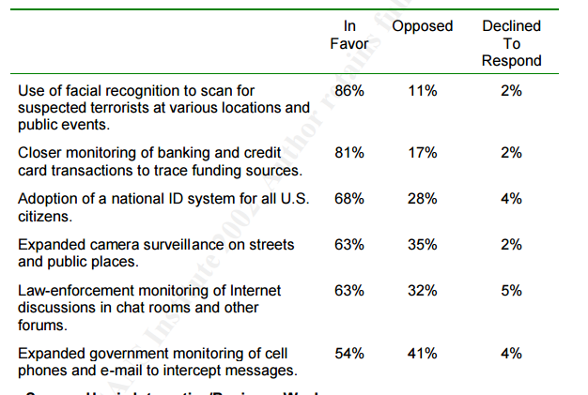

In terms of presenting my information, I use OneNote as it provided the utility to share the information with everyone. In some cases, this links in with emailing as it makes communication easier than emailing. I included storing data, how fingerprint scanners work, the data/spreadsheets and methods. The links are generalized and explained a little bit so that people will understand what the links are actually about and how it will be useful.

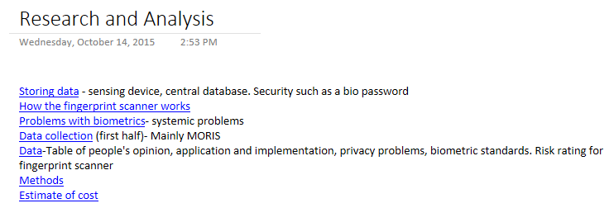

For the means of communication with my team, I used one note to store the information and spreadsheets. It is far more effective than just emailing the websites and spreadsheets that I have found out because my other members of the competence can freely edit the page. It is open to everyone in our group therefore people can utilise what was in the page. Emails require to be constantly sent to the group if editing needs to be done or someone wants to add onto it. Meanwhile, one note will always update itself when something is changed. In this case, OneNote is used to contain the links that contained my information.

An example of an email I sent to gather what my other team mates have researched. I could also add multiple people for that email if I needed to send the message to more than one person. It is resourceful to save a draft of an email you have sent or going to send because, you can look back on what you have sent. Default font and colours will be best to send the message since it does not need to look aesthetically pleasing for a simple message.

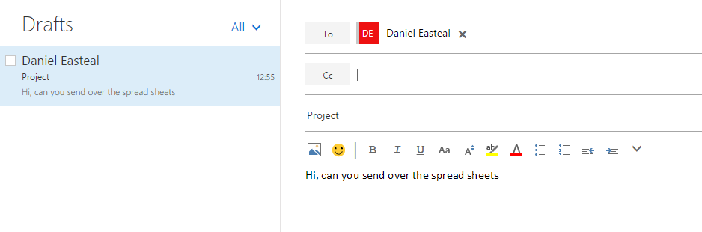

Specialist software: evidence